**LAB 3**

**OOSE**

**Submitted To:** Sir Mukhtiar Zamin

**Submitted By:** Shiza Kabir

(SP20-BSE-081)

Rameen Naeem

(SP20-BSE-057)

Date: 10-10-21

**Use Case Diagram:**

**Fully dressed Use case of Login**

|  |  |
| --- | --- |
| **Use case:** | Login |
| **Primary Actor:** | User |
| **Scope:** | Personal Safety App |
| **Level :** |  |
| **Stakeholders:** | User: user wants a fast and secure system which can help him in the case of any emergency. |
| **Preconditions:** | User must be registered the app. |
| **Success Guarantee:** | User is logged in the system. |
| **Special Requirements:** |  |
| **Main Success Scenario:** | |
| **Actor Action:** | **System Response:** |
| The user clicks the login button: | The system asks the user to login the system by entering his/her phone number, username, email & password. |
| The user enters his/her username & password: | The system will login the user in his/her account. |
| **Alternative Flow:**  If user enters invalid username or password an error will be generated by the system. The system will ask the user to check and login again. | |

**Fully dressed Use case of Set Profile:**

|  |  |
| --- | --- |
| **Use case:** | Set profile |
| **Primary Actor:** | User |
| **Scope:** | Personal Safety App |
| **Level :** |  |
| **Stakeholders:** | User: user wants a fast and secure system which can help him in the case of any emergency. |
| **Preconditions:** | User must be logged in the app. |
| **Success Guarantee:** | User’s profile will be updated in the system. |
| **Special Requirements:** | Contacts, members, location. |
| **Main Success Scenario:** | |
| **Actor Action:** | **System Response:** |
| The user clicks the set profile button: | The system asks the user to enter his/her contacts and city. |
| The user clicks on save button: | The system will save the profile info of the user. |
| **Alternative Flow:**  If user don’t save the info, the info will be discarded. | |

**Fully dressed Use case of Invoke Emergency**

|  |  |
| --- | --- |
| **Use case:** | Invoke Emergency |
| **Primary Actor:** | User |
| **Scope:** | Personal Safety App |
| **Level :** |  |
| **Stakeholders:** | User: user wants a fast and secure system which can help him in the case of any emergency. |
| **Preconditions:** | 1. User must be logged in the system. 2. User must have enabled the location and have selected the nearest police station. 3. User must have added at least 2 contacts in the system. |
| **Success Guarantee:** | Emergency message sent successfully. |
| **Special Requirements:** | Location must be enabled. |
| **Main Success Scenario:** | |
| **Actor Action:** | **System Response:** |
| The user press the emergency button: | The system will send an emergency alert to the contacts added by the user with location URL. |
| **Alternative Flow:**  If location is not enabled the user won’t be able to press the emergency button. System will ask the user to enable the location first to send an emergency message. | |

**Fully dressed Use case of Give Feedback**

|  |  |
| --- | --- |
| **Use case:** | Give Feedback |
| **Primary Actor:** | User |
| **Scope:** | Personal Safety App |
| **Level:** |  |
| **Stakeholders:** | User: user wants a fast and secure system which can help him in the case of any emergency. |
| **Preconditions:** | User must have Installed the app. |
| **Post Condition:** | None. |
| **Main Success Scenario:** | |
| **Actor Action:** | **System Response:** |
| The user clicks on feedback button: | The system will ask the user to write the remarks for the app. |
| The user gives feedback: |  |
| The user submits the feedback: | The system saves the user feedback. |
| **Alternative Flow:**  None | |

**Brief Level Use Cases:**

**Login:**

This use case starts after installing and registering in the application, as a user opens the app a login page will be displayed to him by the system where he has to enter his username and password to login the system. The use case ends.

**Set Profile:**

This use case begins when user login the system and needs to enter the information i.e. name and number of the monitor and his city to send an emergency alert in any emergency situation to the contacts he wants to. After adding the required info in his profile, he will save the information. The use case ends.

**Invoke Emergency:**

This use case begins when user is already registered and logged in the system and has enabled his/her tracking. Whenever the user is in an emergency, he/she simply opens the app, this use case appears as an emergency button with the option of selecting the nearest police station and sending alert to his contacts and police station. The emergency message will be sent by the system with the location URL of user. The use case ends.

**Give Feedback:**

This use case starts when the user wants to give any kind of feedback about the app. User will simply goes to the menu section there, he will find an option of give feedback by clicking the system will take user to the blank page where user can write suggestions and remarks about the app. The use case ends.

**Domain Model:**

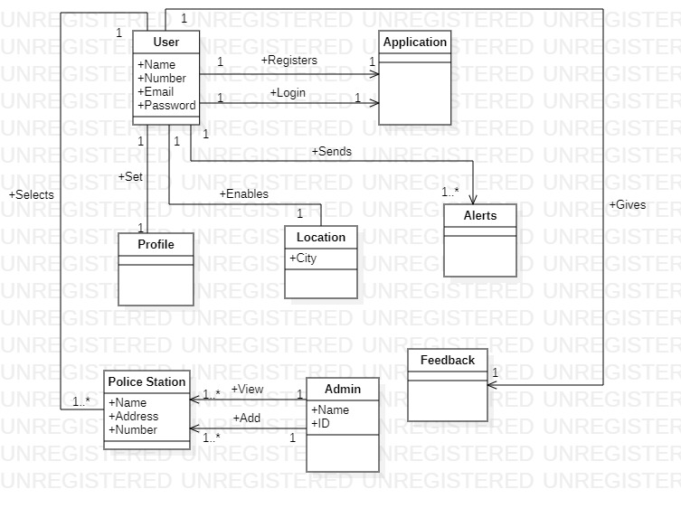

**SSD’s:**

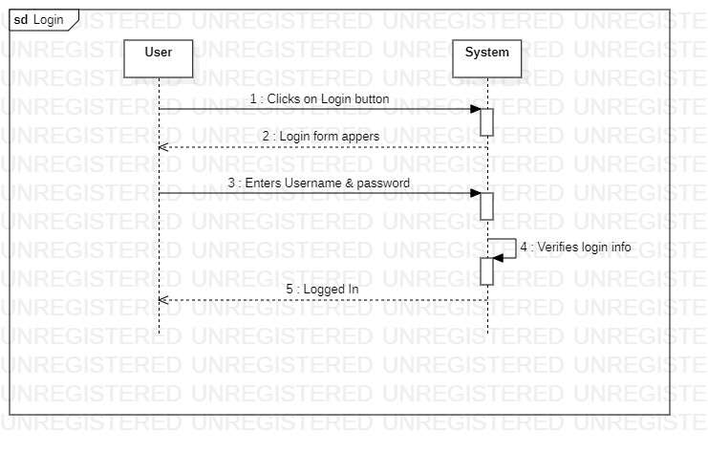

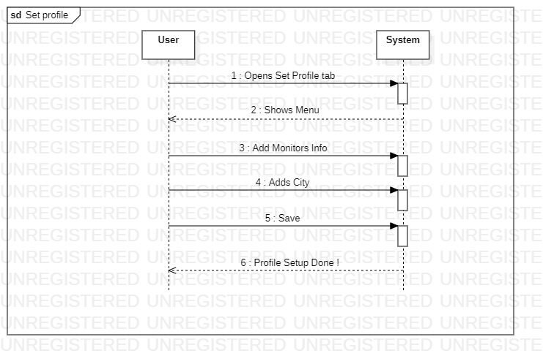

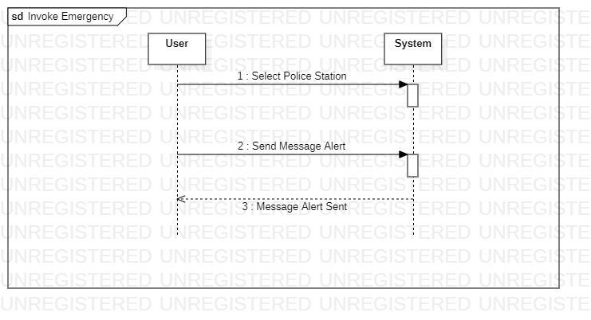

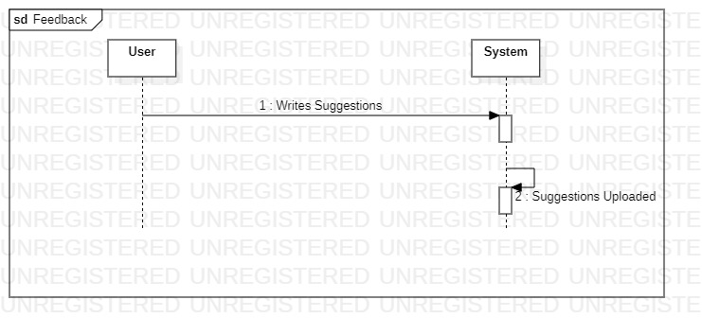

**Operation Contracts:**

|  |  |
| --- | --- |
| **Operation:** | login |
| **Cross reference:** | Use case: Login |
| **Pre-condition:** | User is registered and authenticated in the system |
| **Post-condition** | User logged in the system |

|  |  |
| --- | --- |
| **Operation:** | Add City |
| **Cross reference:** | Use case: Set Profile |
| **Pre-condition:** | User is logged in the system |
| **Post-condition** | City was added and saved. |

|  |  |
| --- | --- |
| **Operation:** | Add Monitors |
| **Cross reference:** | Use case: Set Profile |
| **Pre-condition:** | User is logged in the system |
| **Post-condition** | Monitors was added in the profile. |

|  |  |
| --- | --- |
| **Operation:** | View Monitors |
| **Cross reference:** | Use case: Set Profile |
| **Pre-condition:** | User is logged in the system |
| **Post-condition** | Monitors list was displayed |

|  |  |
| --- | --- |
| **Operation:** | Send Alert |
| **Cross reference:** | Use case: Invoke Emergency |
| **Pre-condition:** | User is logged in the system |
| **Post-condition** | Emergency message was sent by the system. |

|  |  |
| --- | --- |
| **Operation:** | Select Police Station |
| **Cross reference:** | Use case: Invoke Emergency |
| **Pre-condition:** | User is logged in the system |
| **Post-condition** | Police station was added and emergency message was sent. |

|  |  |
| --- | --- |
| **Operation:** | Give Feedback |
| **Cross reference:** | Use case: Invoke Emergency |
| **Pre-condition:** | User is logged in the system |
| **Post-condition** | Feedback was published. |